**Reliability Test and Improvement of a Sensor System for Person Detection in a Smart Office Automation**

Master of Engineering

Information Technology

Individual Project

Aishin Abdulla Yoosufali

1359022

aishin.abdullayoosufali@stud.fra-uas.de

***Abstract*—This study aims to improve the dependability of smart office automation by recognizing human presence. The Red Pitaya (RP) Ultrasonic sensor system is utilized in this investigation to gather ultrasonic readings for two scenarios: “Person sitting on a Chair” and “Empty Chair/Object”. For classification, supervised machine learning algorithms that incorporate Support Vector Machines (SVM) and Random Forest (RF), have been implemented. Two methodologies are investigated: an independent Ultrasonic sensor model and a combined model that employs both red pitaya sensor systems and cameras. Notably, the accuracies of both models are strikingly identical, illustrating the effectiveness of a stand-alone Ultrasonic sensor system while resolving privacy issues associated with camera integration. This study highlights the capabilities of non-intrusive sensor-based person recognition, making it appropriate for a variety of office areas that require automated lighting modifications depending on human presence, boosting efficiency, and convenience in smart office environments.**

***Keywords— Ultrasonic sensor, Smart office automation, Person detection, Reliability test, Supervised Learning, Non-invasive technology***

# Introduction

# In an age of fast technological innovation, smart office automation has firmly established itself as a cornerstone of efficacy and flawless operations. The use of cutting-edge technologies delivers not only higher productivity but also a more comfortable office environment. Person recognition, which is at the heart of this progression, allows for an extensive variety of smart office applications, from space optimization to energy savings. As an outcome, workplace automation makes systems more accessible, allowing for more open information exchange and generating the possibility of having significant impacts on how the industrial sector and company run. [1]

The significance of accurate person detection is divided into two distinct aspects. First, it permits the powerful utilization of resources, ensuring lighting, heating, cooling, and other commodities are adjusted based on occupancy. The resulting integration not only enhances productivity in operations but also contributes to environmental sustainability by lowering wasteful energy consumption. Furthermore, an effective identification system enables various customizations and context-aware services, which improve the user experience. For instance, smart conference space reservations that adjust to real-time occupancy and can adapt lighting configurations that customize illumination to human presence are all possible applications.

The first objective of this study is to conduct an extensive evaluation of the performance of the Red Pitaya Ultrasonic sensor system. This evaluation includes a thorough examination of its positive and negative aspects in the area where it also provides differentiation and accurate detection in two scenarios such as, “Person Sitting on Chair” and “Empty Chair/Object”. Secondly, this research also incorporates an already built and tested experiment by integrating the Ultrasonic sensor system alongside camera inputs. [2] In this approach, a graphical user interface (GUI) is being developed, which acts as a bridge between the sensor and the camera. This hybrid model acts as a data acquisition channel, where the readings are captured from an Ultrasonic sensor and synchronized with the visual data from the camera. By using the YOLOv5 algorithm, the model will predict the readings from the combined sensor and camera inputs and label the measurements. [2]

The intention is to accomplish this scrutiny by comparing the stand-alone Ultrasonic model with the hybrid system and delving into the unique limitations of each approach. The stand-alone model demonstrates the possibilities of sensor-driven human detection, while on the other hand, the combined model utilizes both sensor and camera for precise labeled results.

As a part of my research, I am conducting a comparison between these two models to determine which one is better at detecting people accurately in smart office settings. By looking closely at each model’s limitations, it will be easier to tell which approach is the smarter choice for creating structures that work even smarter. The second section explains the theoretical background of the research, which includes the architecture of the experiment for both models. The third section consists of the methodology of this study. The fourth part will show the results of all the analyses conducted during the research. Eventually, I will draw the conclusions and future scope of this experiment in the pursuit of advancing smart office automation.

# II. Related Work

## Red Pitaya

Red Pitaya is an FPGA-based data acquisition board mainly used for the development of its measurements. A red pitaya board typically has four analog signals, of which two are RF inputs and the other two are RF outputs, as well as ADC (analog-to-digital) and DAC (digital-to-analog) converters. [3] On one of the input connectors, an Ultrasonic sensor is connected. The Red Pitaya is free and open-source software. This means that the sensor's functionality can be coded freely and independently based on our needs, and many previously created programs can be found on the Internet's open-source networks. In this study, the red pitaya is connected using a wireless network, and a separate connection is established with the red pitaya board through a power supply.

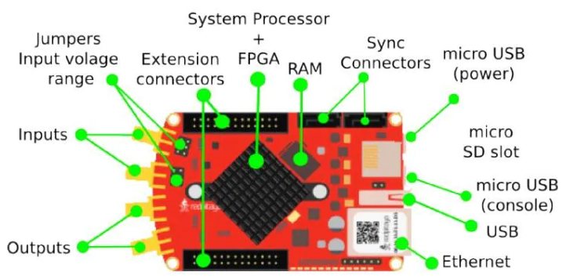

Fig 1. Red Pitaya [4]

## Ultrasonic Sensor for Human Detection

An ultrasonic sensor works such that it sends out high-frequency sound waves that are too high-pitched for humans to hear. For instance, a bat uses its sound instead of any visual sight to see things around it. The bat emits high-pitched sounds and listens to their echoes to understand the path to follow. The sensor emits the first sound wave and, in the meantime, starts the timer to keep track of the time for that same sound wave to bounce back to the sensor. Through this process, the sensor figures out the distance of an object or a human from the sensor. Now let’s dive into how the ultrasonic sensor operates and the principles that underpin its capabilities.

The ultrasonic sensor is connected to one of the input pins of the red pitaya board. The input pins of red pitaya receive the ultrasonic or analog signals that are being generated by the sensor as echoes, which bounce back from a human or object. Afterward, these analog signals are in continuous voltage form. The Red Pitaya’s ADC converter samples these analog signals at a specific rate, which converts the varied signals or voltages into a series of digital values. The sequence of digital values obtained from ADC is represented in the time domain. The built-in RP’s GUI provides or adds a feature that performs a Fast Fourier Transform (FFT) on the acquired time-domain data. FFT is a mathematical algorithm that converts time-domain data into frequency-domain data. This process helps to analyze different frequencies present in the received signals.

# III. Methodology

## Data Collection

Let’s now delve into the core of the research with the data collection; this is the essential building block of the model’s training and performance evaluation. The measurements were carefully chosen to cover a range of scenarios, enabling both stand-alone and hybrid models to be particularly effective at recognizing key distinctions. Here’s an outline of how the dataset in different aspects is structured.

1. For Stand-Alone Model:

Person Sitting on Chair and Empty Chair (Female):

In this category, datasets are being gathered with 35,000 measurements specifically for training the SVM model, along with an additional 15,000 measurements for testing the performance evaluation. With this data, the model distinguishes between a female person sitting on a chair and an empty chair.

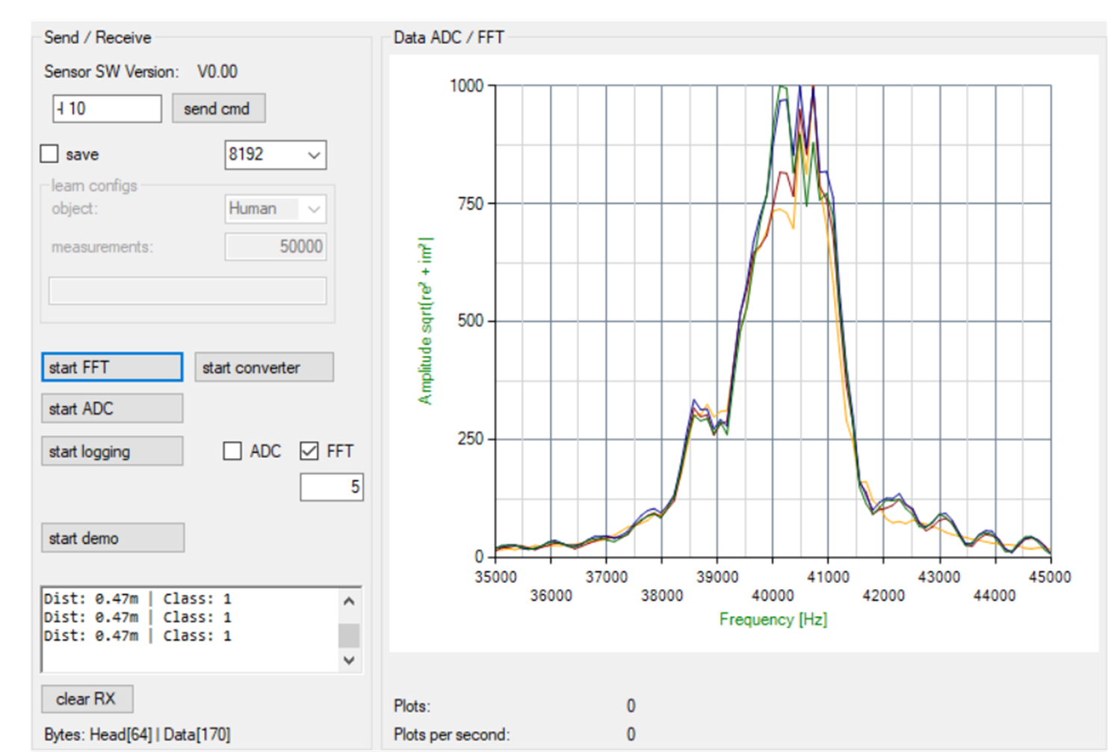

Fig 2. Person Sitting on Chair measurement plot

Person Sitting on Chair and Empty Chair (Male):

For this category, a compiled dataset was taken with 10,000 measurements for training and 5,000 measurements for testing. This data enables the SVM model to differentiate between a male person sitting on a chair and an empty chair.

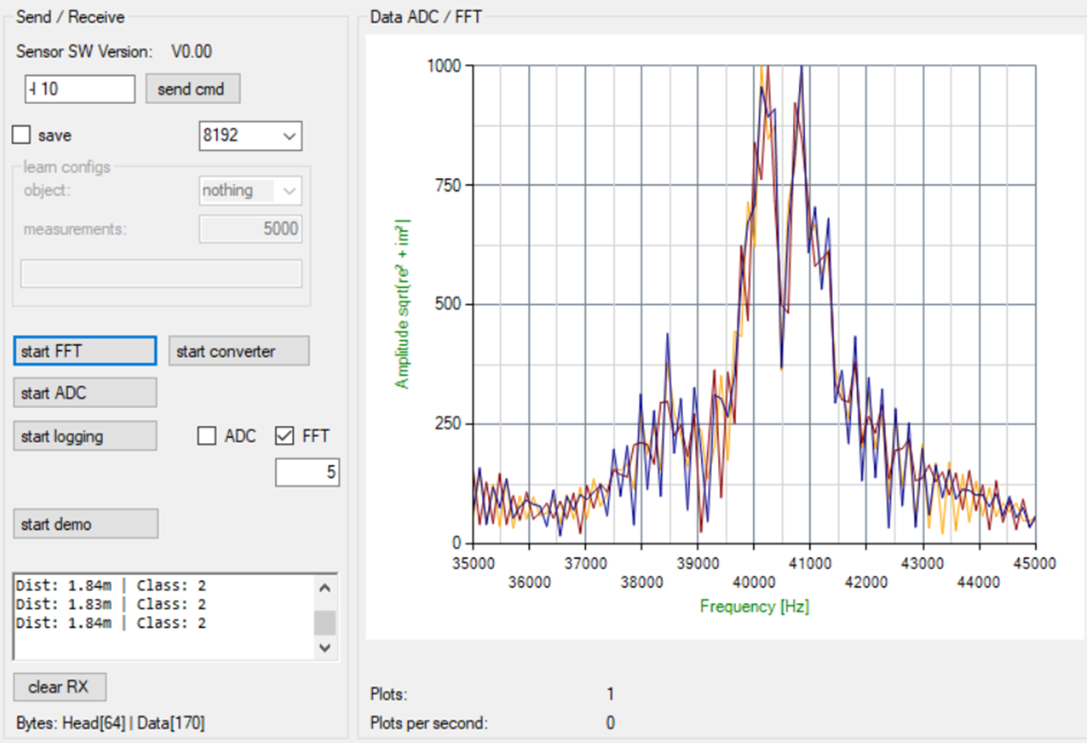

Fig 3. Empty Chair measurements plot

1. For the Hybrid Model:

Person Sitting on Chair and Empty Chair Datasets:

In the case of a hybrid model, data is collected using sensor and camera inputs and saved in both binary and image formats. For RF model training, those binary files are converted into CSV files or tabular forms to train and test the models. For training the model, 25,000 measurements were taken, and to test the same model, 10,000 measurements were taken and prepared.

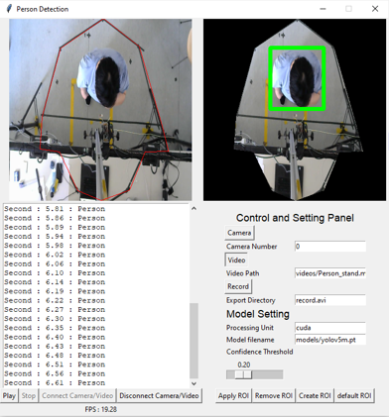

Fig 4. Person Detection Software [2]

A solid foundation has been built for training and evaluating both models by curating these datasets with careful consideration of different scenarios, such as lighting conditions, opened and closed windows or doors, and individual characteristics. These approaches ensure that both models are being trained and tested in a wide range of situations and are capable of dealing with these circumstances to produce accurate results in real-world settings.

*B. Feature Extraction*

After data collection, the feature extraction process takes place. By harnessing the potential of ultrasonic sensors, measurements differ between “Person Sitting on Chair” and “Empty Chair”. Starting with raw data directly from the sensor and utilizing Red Pitaya’s ADC converter to transform these raw data signals into digital signals in the time domain. In Red Pitaya’s code, the FFT technique is programmed for the GUI interface, such that this time-domain information is then programmed in such a way that the FFT technique is introduced into the GUI interface, where this adc information is converted to frequency-domain signals.

This transformed data revealed the unique frequency components present in each scenario. Instead of further manipulation, the whole dataset for both the “Person Sitting on Chaoir” and “Empty Chair” categories is employed as features for training the SVM model. By directly feeding this raw data into the model, allowing it to independently learn and understand the differences between the two sets of data collection. This optimized procedure improved the SVM model’s ability to distinguish between a person sitting in a chair and an empty chair for smart automated office spaces, resulting in accurate and reliable classifications.

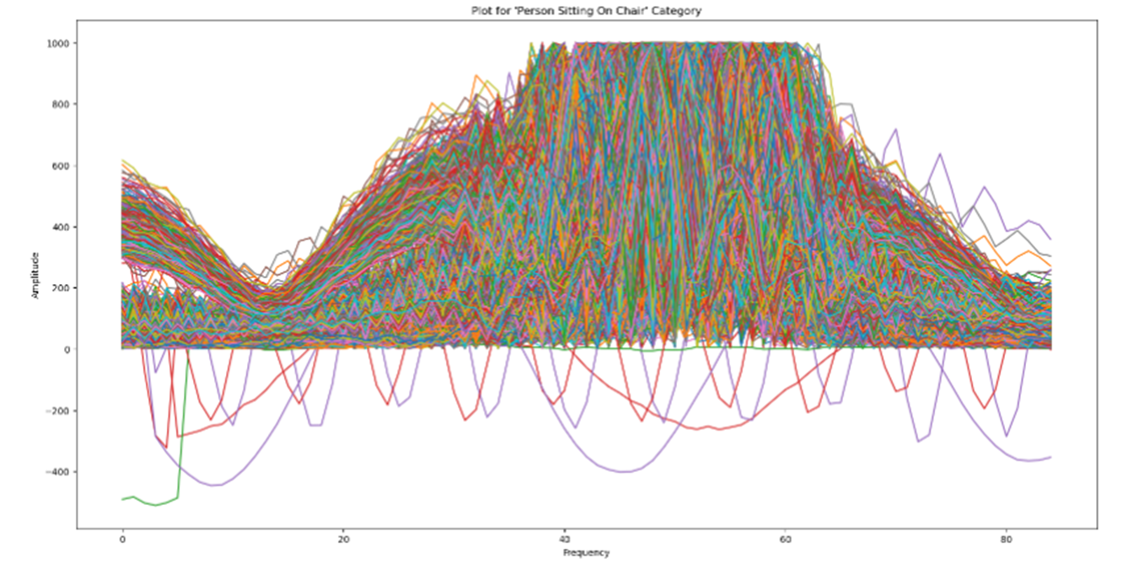

Fig 5. Person Sitting Dataset plot

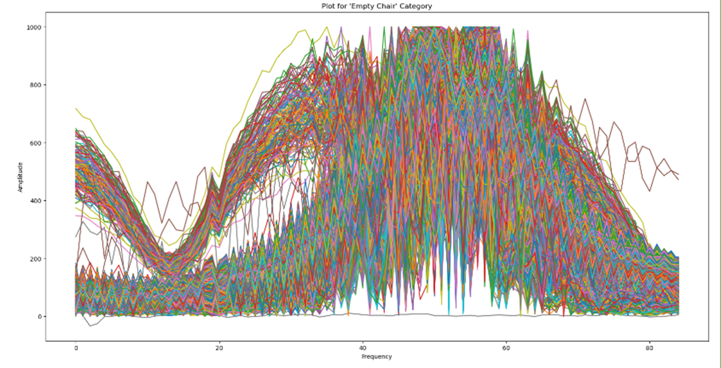

Fig 6. Empty Chair Dataset Plot

## C. Experimental Setup

The experimental setup serves as another foundation for the model's development and testing, as this study primarily focuses on the smart office space. In both cases, stand-alone and hybrid models were meticulously designed in an environment that emulated real-world scenarios. The design of the setup is as follows:

1. For the Ultrasonic Sensor Stand-Alone model:

The core setup for the experiment revolved around the red pitaya and ultrasonic sensor system with a user-friendly GUI interface at a suitable height so that the setup has a chair placed directly below the sensor with a person seated on it, or it can be an empty chair. This arrangement allowed the sensor to capture accurate readings and echoes diverting back to the sensor, which produced unlabeled data, by keeping in mind that this whole setup resembles the office setup where the lights are above a person for efficient energy consumption.



Fig 7. Person Sitting on a Chair and Empty Chair Scenario

1. For the Ultrasonic Sensor and Camera (Hybrid) model:

For this model, the setup shared similarities with the stand-alone arrangements. The Red Pitaya system remained pivotal, though along with that, an already prepared and tested YOLOv5 model was utilized [2] to capture the image inputs, adding a visual dimension to the labeled data. This setup involved the same chair and person scenario, and the laptop facilitated the collection of appended visual or classified information.

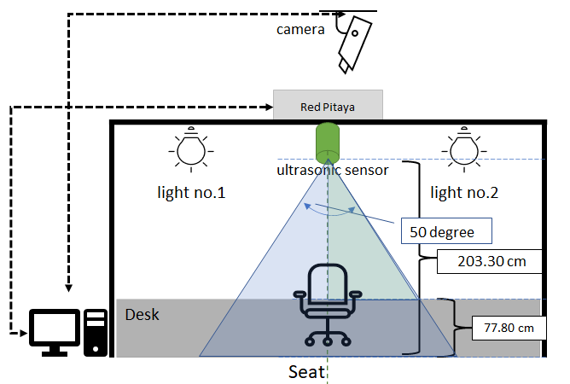 Fig 8. Experimental Setup for both models [2]



Fig 9. Smart Office Space with different Objects

## D. Algorithm

This research proposes a neural network-based examination for identifying humans or objects. The method of enhanced human detection and classification using supervised machine learning algorithms includes gathering data, data preparation, extraction of features, model development, model assessment, and deployment. [5]

This approach resembles intellectual, practical examples instead of theoretical exposure. The underlying patterns and distinct attributes are deeply embedded in the model, allowing it to gain insight from perfect examples, which enables informed decision-making.

In the pursuit of refining the efficacy of human detection in smart automated office space, within the context of ultrasonic sensor measurements, a deliberate reading from an unoccupied chair. A unique approach was taken into consideration, instead of taking these datasets and performing any data pre-processing or feature engineering [6], the decision was made to present these datasets to the model in their raw, unprocessed state. The intention behind this unconventional technique was rooted in the belief that the model, when presented with untreated data, will have the ability to recognize the inherent disparities present in the act of a person occupying a chair versus an empty one. By learning from raw measurements, the model could uncover hidden patterns and make smart decisions on its own.

In the quest to determine an appropriate model for this specific endeavor, such as a stand-alone model, the Support Vector Machine (SVM) emerged as the leading possibility. Tax Duin [7] used a Support Vector Machine (SVM) to contribute to object classification by performing outlier detection or novelty detection. V. Matz et al. [8] also describe the use of SVM to categorize objects into two groups. SVM’s heritage in classification tasks finds resonance with the current research objectives. It uses a precise methodology to outline the boundaries between categories, which are similar to how genres are defined in literature. The specific method has some sort of trick, which lies in finding the best way possible to separate things. For instance, it is like the world’s most precise gardener who outlines the branches in such a way that the plants grow exactly how you want. Similarly, SVM pinpoints the difference between categories by creating a boundary that maximizes the gap between them. SVM’s tendency for detecting small distinctions in datasets is perfectly suited to the subtle variations inherent in ultrasonic sensor measurements. Furthermore, SVM’s ability to work with messy, non-linear data made it the perfect choice for understanding the complexities of ultrasonic sensor readings and classifying the presence and absence of a person occupying a chair.

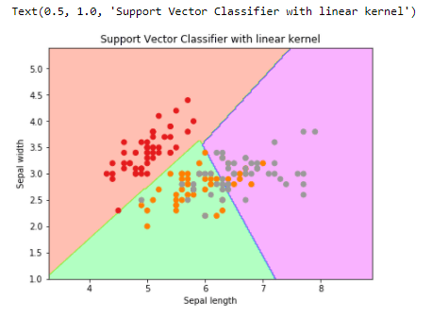 Fig 10. SVC algorithm workflow [9]

Below are some of the code snippets that demonstrate the implementation of SVM in a stand-alone model:

### Importing Libraries:

Begin with importing the necessary libraries and modules, including those for data processing, SVM, visualization, and more.

| import numpy as np  import pandas as pd  from sklearn.svm import SVC  import matplotlib.pyplot as plt  import seaborn as sns |
| --- |

### Load and Combine Data:

Loading the person sitting and empty chair datasets in CSV format and combining them into a single comprehensive dataset.

| df_combined = pd.concat([df_person, df_empty], axis=0) |
| --- |

### Set Target Variable:

Formulate target variables by assigning “1” for a person sitting on a Chair and “0” for an Empty Chair.

| target_person = np.ones(len(df_person))  target_empty = np.zeros(len(df_empty))  target_combined = np.concatenate([target_person, target_empty], axis=0) |
| --- |

### Training SVM Model:

Initiate an SVM model with a linear kernel and train it using combined datasets and target variables.

| svm_model_training = SVC(kernel=’linear’)  svm_model_training.fit(df_combined.values, target_combined) |
| --- |

### Saving SVM Model:

| joblib.dump(svm_model_training, “svm_model.pk1”) |
| --- |

Following the successful training and saving of the SVM model, an additional stage of evaluation and validation was initiated. This phase included acquiring new datasets, which captured instances of “Person Sitting on a Chair” and “an Empty chair/Object” respectively. In contrast to the training datasets, the model was unaware of the newly acquired datasets. Nevertheless, the model’s internal understanding of the distinctions between the two categories had been refined as a result of rigorous training on known data patterns. With this newfound knowledge, the trained SVM model was willing to examine the unseen sets of data. By utilizing the insights gained during training, the model was able to precisely categorize and classify scenarios within these datasets. The capability to make distinctions between known categories when presented with novel and previously unseen data demonstrated the model’s ability to adapt and efficacy, encouraging an environment-friendly, person or object detection within the framework of ultrasonic sensor measurements.

The integration of the Red Pitaya Ultrasonic Sensor system and camera inputs resulted in the creation of the hybrid model [2] for person or object detection. Labeled datasets are created through the combination of the aforementioned methods, defining “Person Sitting on a Chair” and “Empty Chair” occasions with precision. The presence of camera inputs significantly enhances the dataset because visual data contains crucial context-related information such as human postures and spatial relationships. Due to its ability to navigate complex data, the Random Forest (RF) algorithm [10] was adopted to assess the effectiveness of the hybrid model. This collaboration aimed to improve person detection accuracy while also providing insights into the model’s adaptability in real-world settings, bridging the gap between sensors and cameras for an all-encompassing approach.

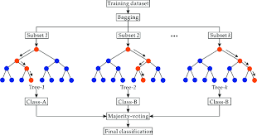 Fig 11. Random Forest ML Algorithm [9]

# IV. Experimental Results

Embarking on the critical phase of evaluating the results of our meticulously designed stand-alone and hybrid models for person detection in a smart office environment for efficient energy consumption. This section provides a thorough examination of both models’ performance, shedding light by providing comprehensive insights about the ability to recognize “Person Sitting on a Chair” events from “Empty Chair” scenarios. This reveals the capabilities of innovative approaches through rigorous testing and metric analysis.

1. Results for Stand-Alone Model:

The stand-alone model has been determined to have commendable proficiency in person detection after extensive testing and evaluation. The SVM algorithm demonstrated its remarkable capacity to discriminate between “Person sitting on a Chair” and “Empty Chair” cases when trained with Red Pitaya Ultrasonic Sensor measurements. The model’s accuracy impressively reached 0.9843, illustrating its ability to perform classification tasks. Furthermore, the precision, recall, and F1-score metrics, with values of 0.9864, 0.9821, and 0.9842, respectively, contributed to a comprehensive understanding of the stand-alone model’s performance.

| Performance Metrics | Model’s Performance |
| --- | --- |
| Accuracy | 0.9843 |
| Precision | 0.9864 |
| Recall | 0.9821 |
| F1-score | 0.9842 |

Table 1. Performance Metrics of Stand-Alone Model

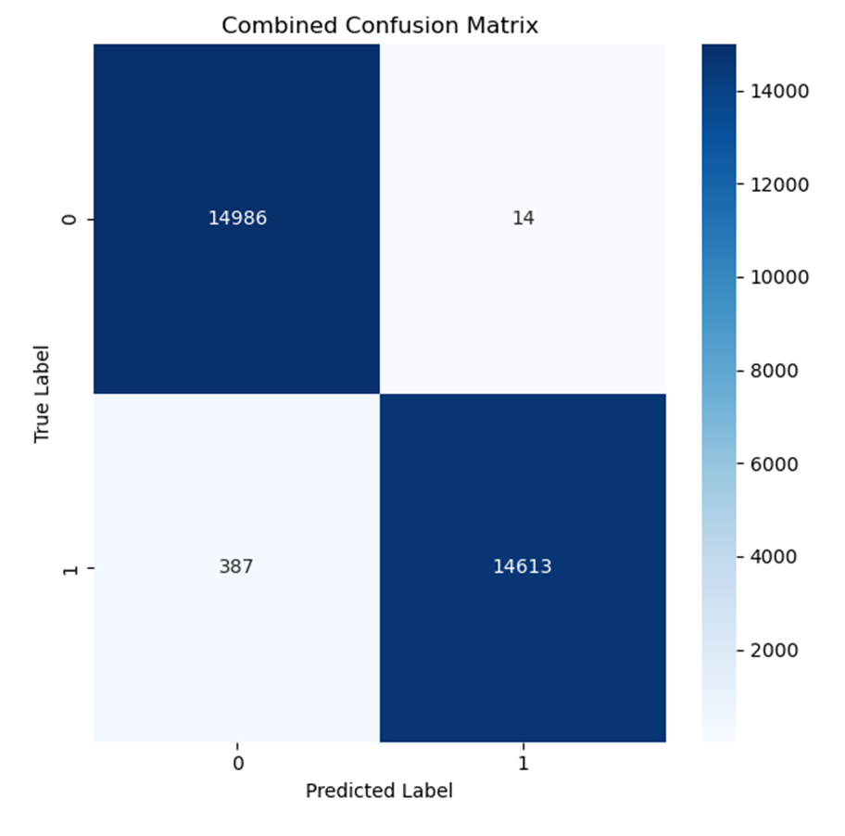

Fig 12. Confusion matrix for Stand-Alone model testing

The results shown below provide vital insights into the model’s performance when differentiating between entirely different chair settings and a male individual. The confusion matrix plot helps to evaluate the model’s efficacy by providing an understandable representation of its classification accuracy.

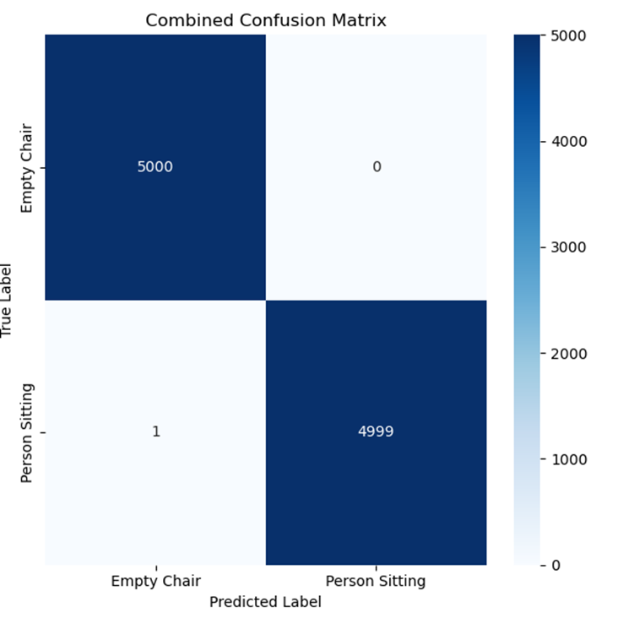

Fig 13. A confusion matrix for different people (male) and different empty chairs

1. Results for Hybrid Model:

The hybrid model’s combination of ultrasonic sensor measurements and camera inputs produced favorable outcomes. The Random Forest (RF) algorithm, which is capable of dealing with complex data, exhibited an extraordinary capacity to detect people labeled as “1” and empty chairs labeled as “0” in the experimental space. The hybrid model achieved an accuracy of 0.98 by leveraging the collaborative effort between sensors and cameras. Notably, the integration of visual cues from camera inputs significantly improved the hybrid model’s overall accuracy, confirming the beneficial effects of such an integrated approach.

| Labels | Accuracy | Precision | Recall | F1-score |
| --- | --- | --- | --- | --- |
| 0 | 0.98 | 0.99 | 0.97 | 0.98 |
| 1 | 0.98 | 0.97 | 0.99 | 0.98 |

Table 2. Performance Metrics of Hybrid Model

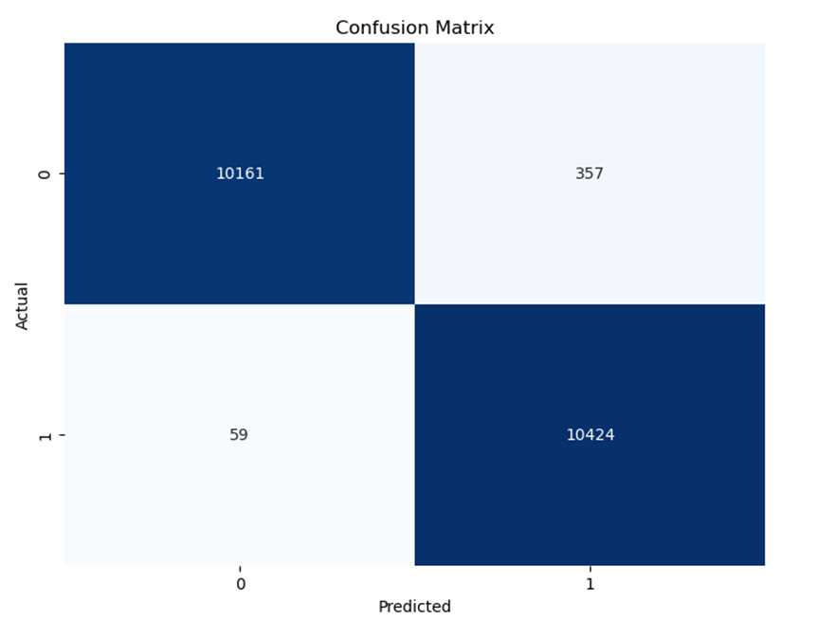

Fig 14. Confusion matrix of Hybrid model testing

# IV. Conclusion and Future Scope

In concluding this experiment, a significant finding emerges: both the stand-alone model, which primarily relies on the Red Pitaya Ultrasonic Sensor System, and the hybrid model, which incorporates sensor systems and camera inputs, demonstrate remarkably comparable accuracy in distinguishing humans from things like chairs. While both models have unique benefits, the stand-alone model particularly shines, when considering its wider impacts. In today’s connected world, privacy issues weigh heavily, and the stand-alone model, which was deliberatively designed with confidentiality in mind, emerges as an intriguing alternative. This concept appears compelling in the modern marketplace, where protecting personal identity and data is crucial.

The findings have far-reaching practical implications; the stand-alone approach provides a seamless, privacy-conscious way to improve resource management and boost user experiences in automated office environments. In the future, real-time datasets can be used in research, allowing for algorithm training and testing in dynamic office scenarios. Evaluating the model’s real-time responsiveness will be essential for practical implementation, providing quick and effective reactions to changing situations. This innovative approach offers not just improved performance but also a larger possibility of using office spaces for better control over lighting and different electrical devices.

# IV. Acknowledgement

I take this opportunity to extend my heartfelt gratitude to Professor Dr. Andreas Pech; his invaluable contributions throughout the project are evident in his consistent guidance, careful evaluation of the experiment’s progress, and thoughtful input. This endeavor would not have been achievable without the generous support of Professor Julian Umansky, who assisted with hardware-related challenges.

# References

[1]. Renuka B., Saniya A., “Design and Implementation of Smart Office Automation System”, International Journal of Computer Applications (0975 – 8887), Volume 151 – No.3, October 2016

[2]. Paween Pongsomboon, “Using Image Processing for Autonomous Illumination Sensor Optimization”, Frankfurt University of Applied Sciences, 2022

[3]. Beatriz R., Alejandro R., et al., “Design and Validation of an FPGA-Based Configurable Transcranial Doppler Neurofeedback System for Chronic Pain Patients”, *Sensors* 2018, *18*(7), 2278; <https://doi.org/10.3390/s18072278>

[4]. Red Pitaya, ”<https://en.wikipedia.org/wiki/Red_Pitaya_(computer)>”

[5]. Cheruku B.G., Gudipudi T., et al., “Improved Human Detection and Classification using Supervised Machine Learning Algorithms”, 8th International Conference on Communication and Electronics Systems (ICCES 2023)

[6]. Anubha P., Apoorva P., et al., “Data Preprocessing and Feature Selection Techniques in Gait Recognition: A Comparative Study of Machine Learning and Deep Learning Approaches”, Pattern Recognition Letters, May 2023

[7]. Duin, Robert PW, et al. "Feature-based dissimilarity space classification." Recognizing Patterns in Signals, Speech, Images and Videos. Springer Berlin Heidelberg, 2010. 46-55.

[8]. V. Matz, M. Kreidl, R. Šmíd, Classification of ultrasonic signals. The 8th International Conference of the Slovenian Society for Nondestructive Testing, Application of Contemporary Non-Destructive Testing in Engineering, September 1-3, 2005, Portorož, Slovenia, pp. 27-33.

[9]. Seven most popular SVM Kernels, “<https://dataaspirant.com/svm-kernels/>”

[10]. Ernest Y.B., Joseph O., Daniel, “Abaye, Basic Tenets of Classification Algorithms K-Nearest Neighbor, Support Vector Machine, Random Forest and Neural Network: A Review”, Journal of Data Analysis and Information Processing, 2020